Project 2

CIS424

<picture>

Grail login ID: peparian

**Description of the Code:**

The python IDE used in this project was IDLE, that is prepackaged with version 3.6. The program is structured with the entry point at the global level,

**Probelsm:**

**The list of tokens are strings, this needed to be compensated when converting to int or float**

**Needed to change the dictionary pointing to a list back to to a regular dictionary. I did not need to store the type, I will just read the type directly**

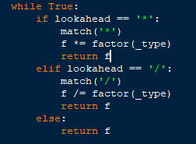

**To**

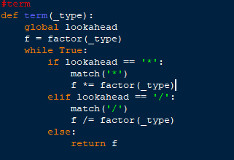

**Because**

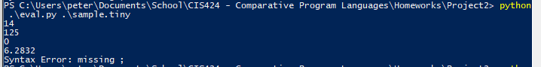

Had to change expr() for the same reason

When a float is being added to an int, it should fail. But when using float(), it converts an int to a float, NOT throwing ValueError. This would result in a pass.

Bonus:

There was a missing semicolon in the code.